* **Activity 3:**

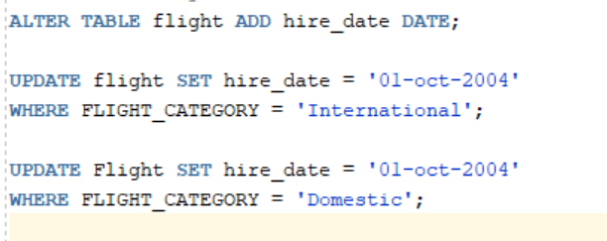Use of Date Functions

Output:

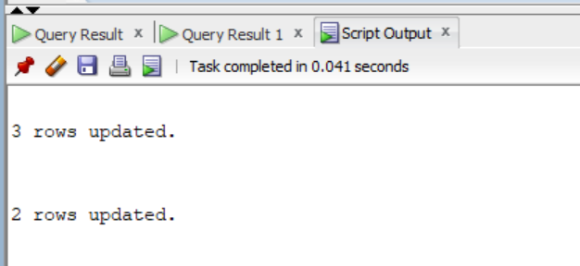

1. **Display the last name and number of weeks employed:**

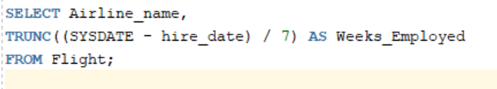

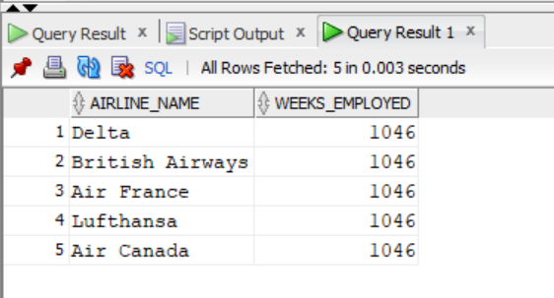Output:

1. **Display employee number, hire date, number of months employed, six-month review date, first Friday after hire date:**

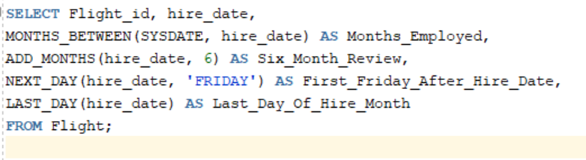

Output:

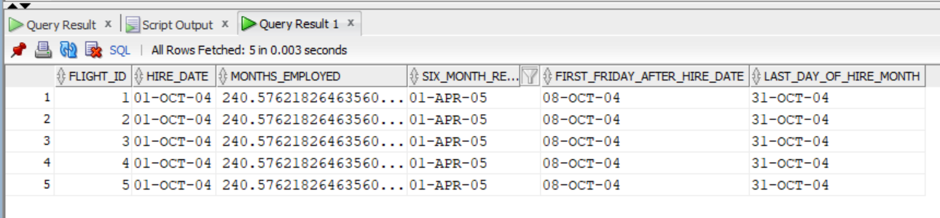

1. **Display employees who started in 2004:**

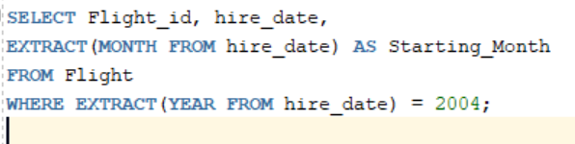

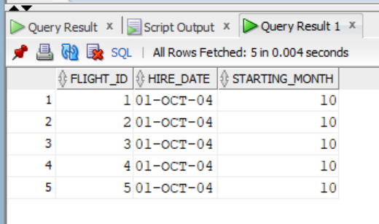Output: